

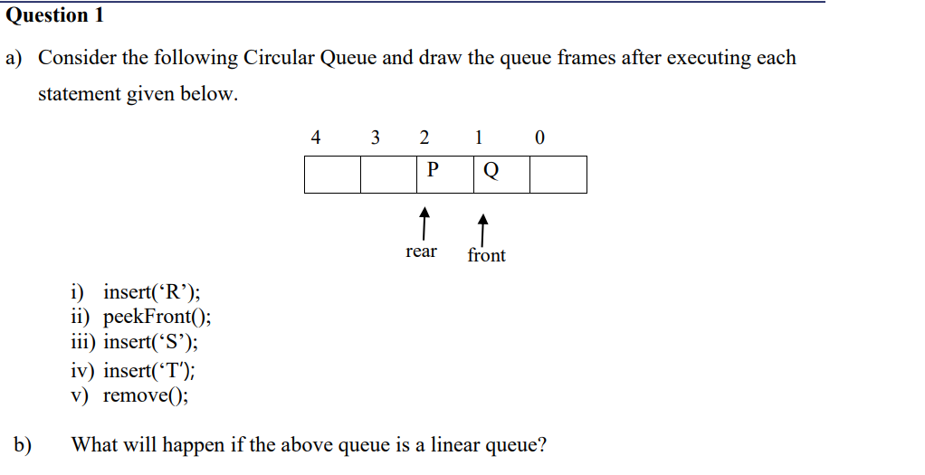

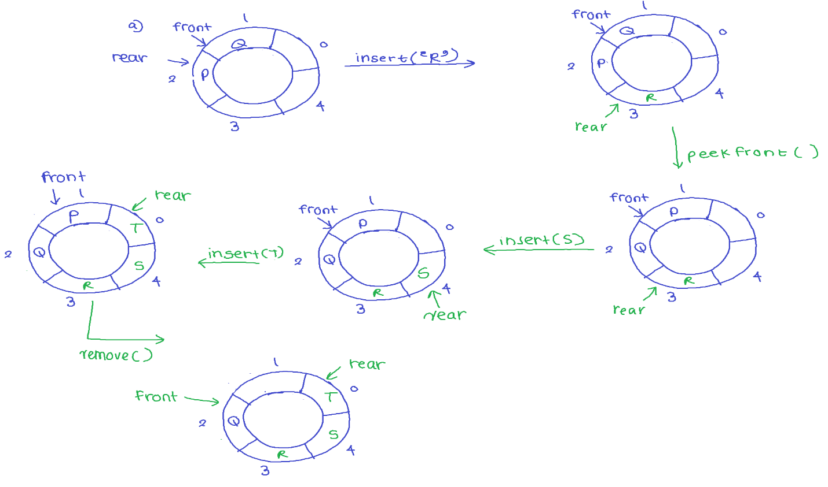

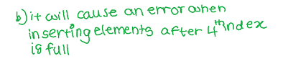

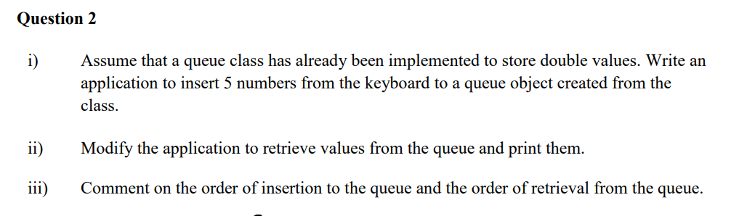

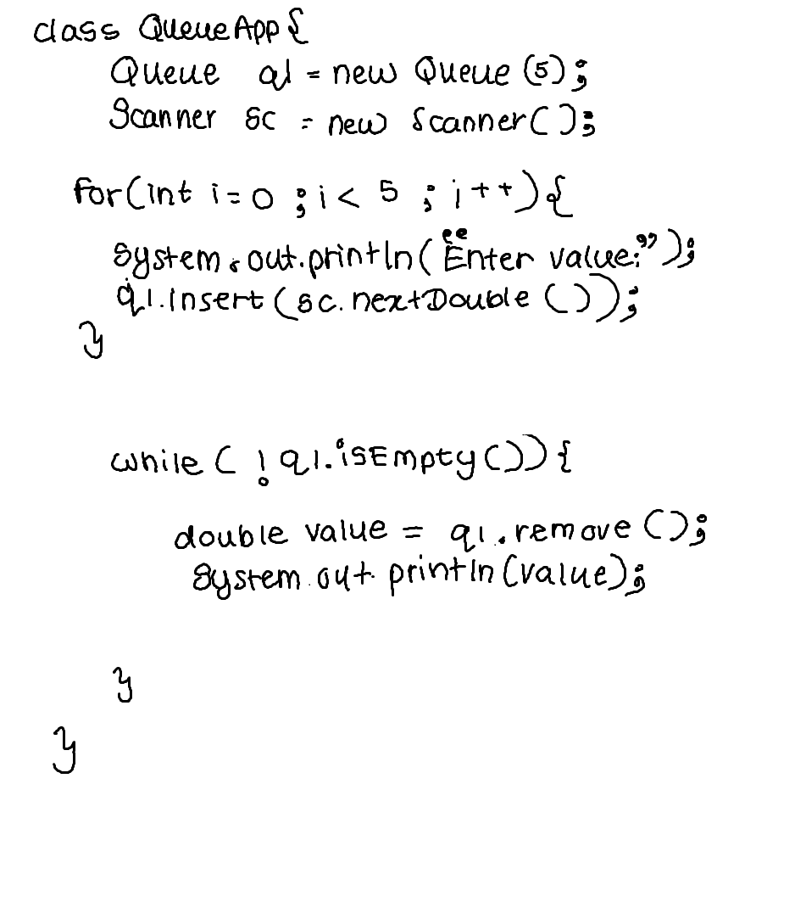

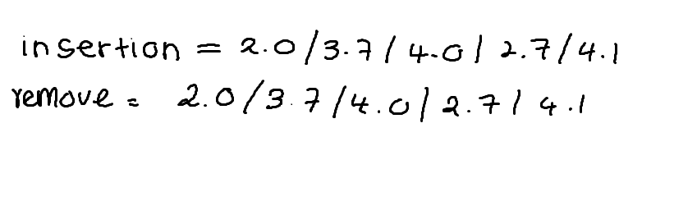

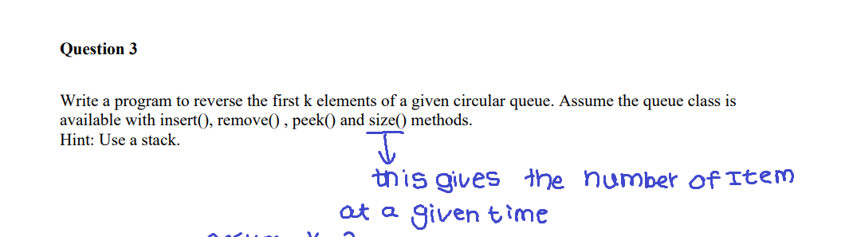

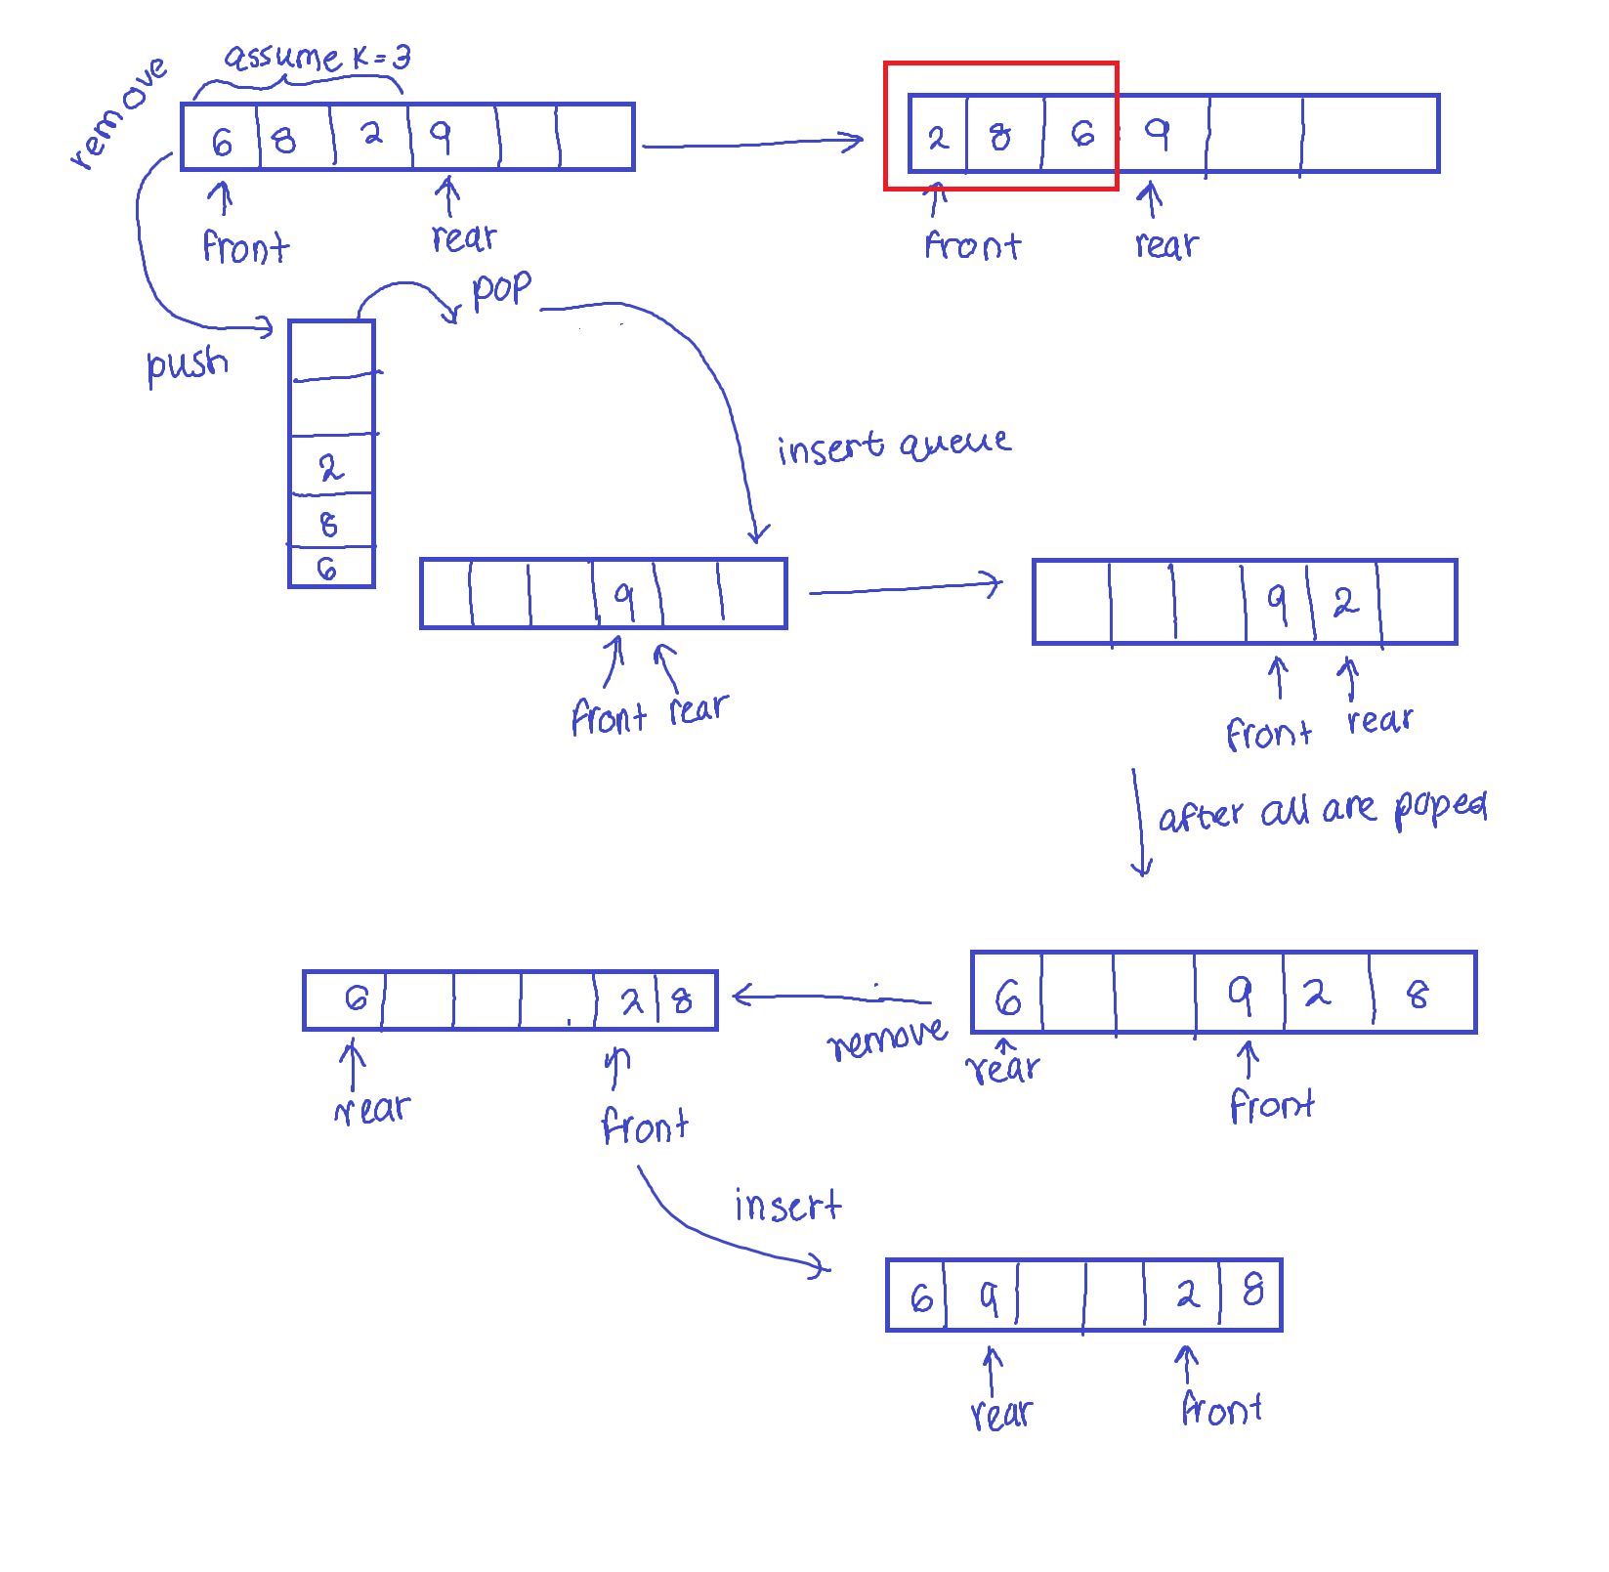

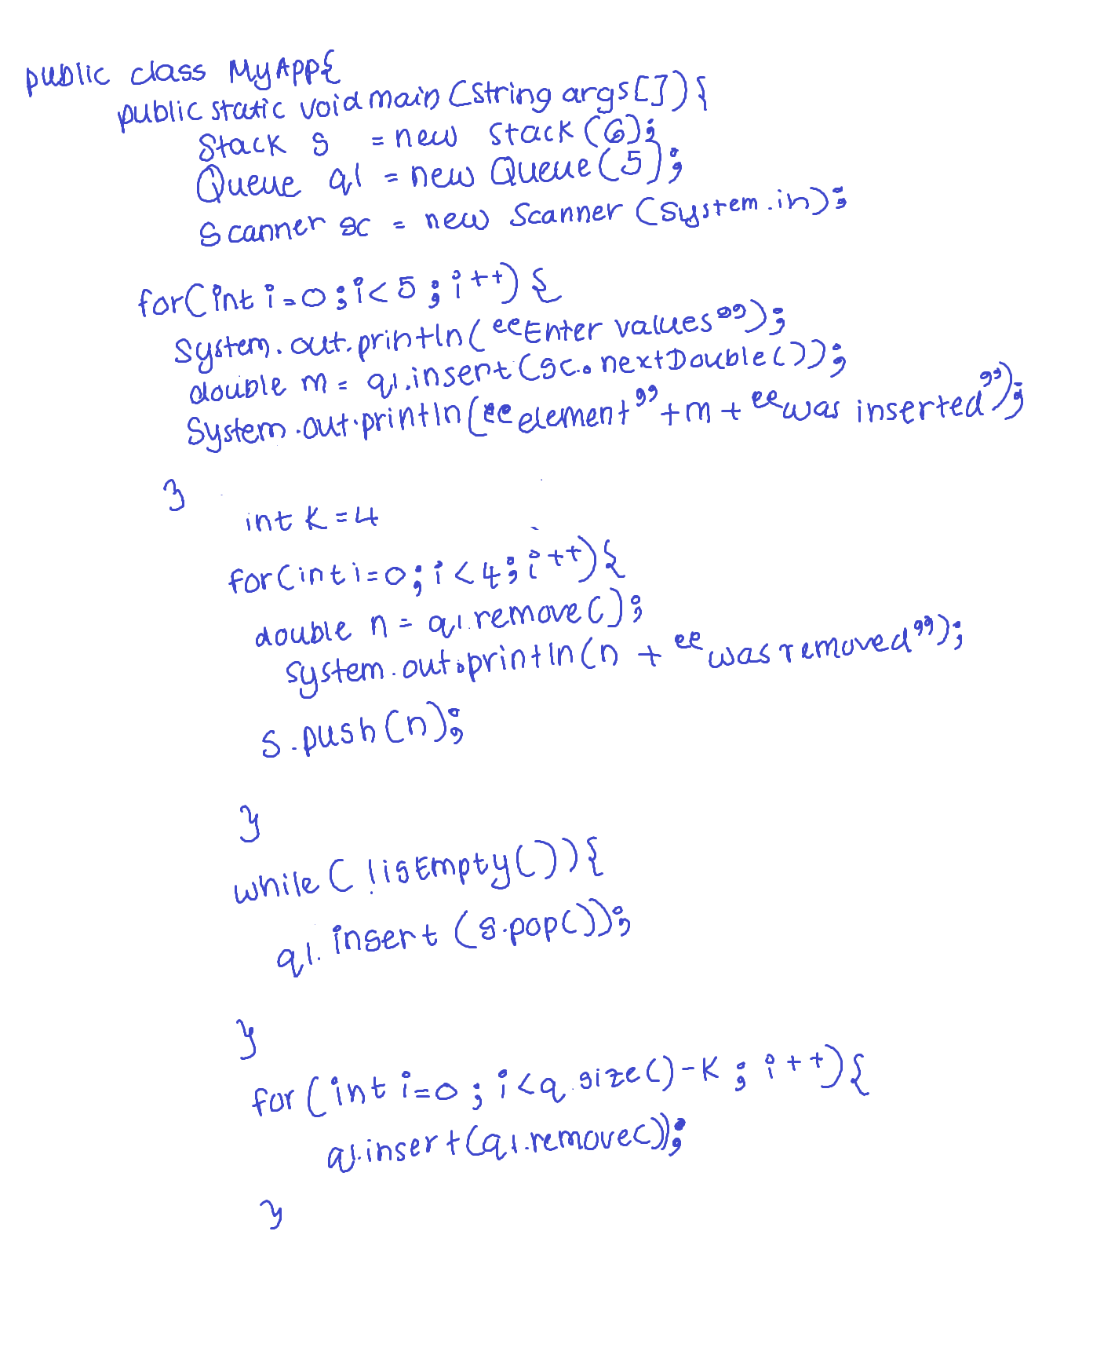



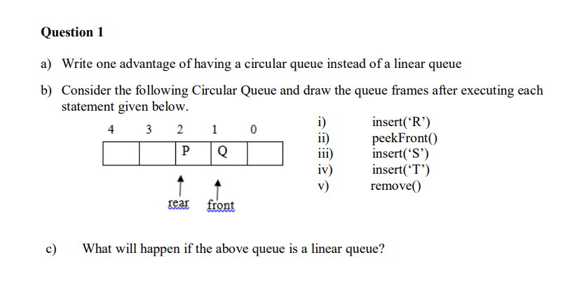

1. Circular Queues avoid the issues with having empty slots in the queue by resetting the rear once the rear has reach the end of the queue but the queue isn’t full. we can use the empty slots to insert values into the queue

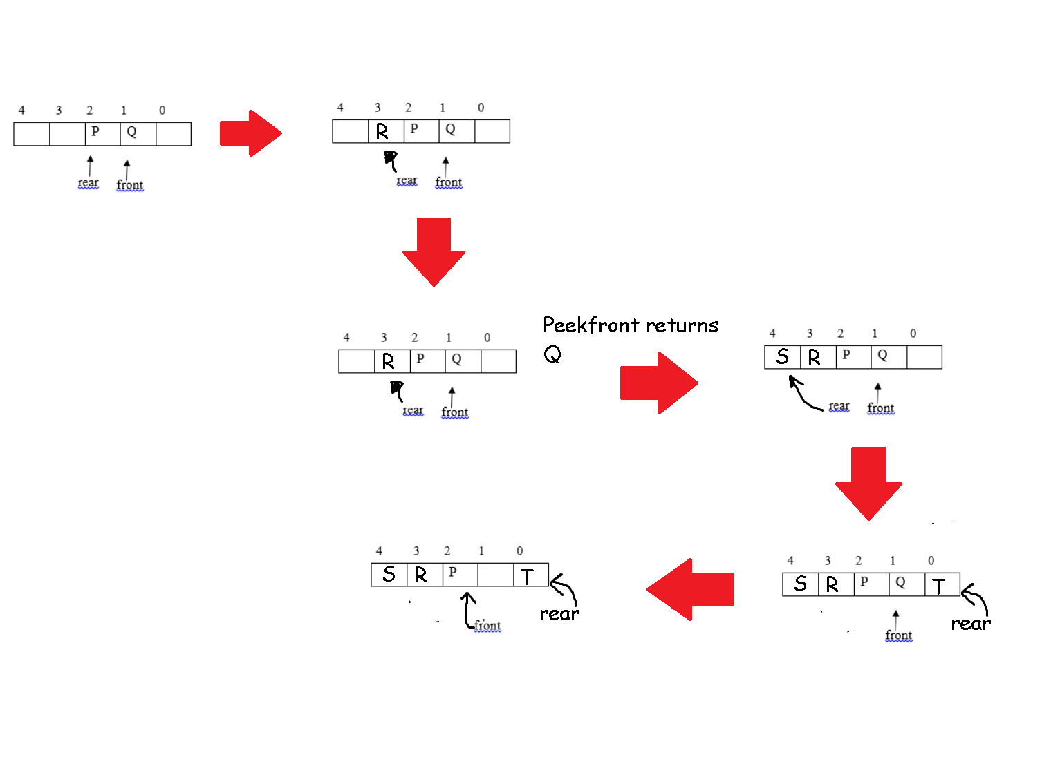



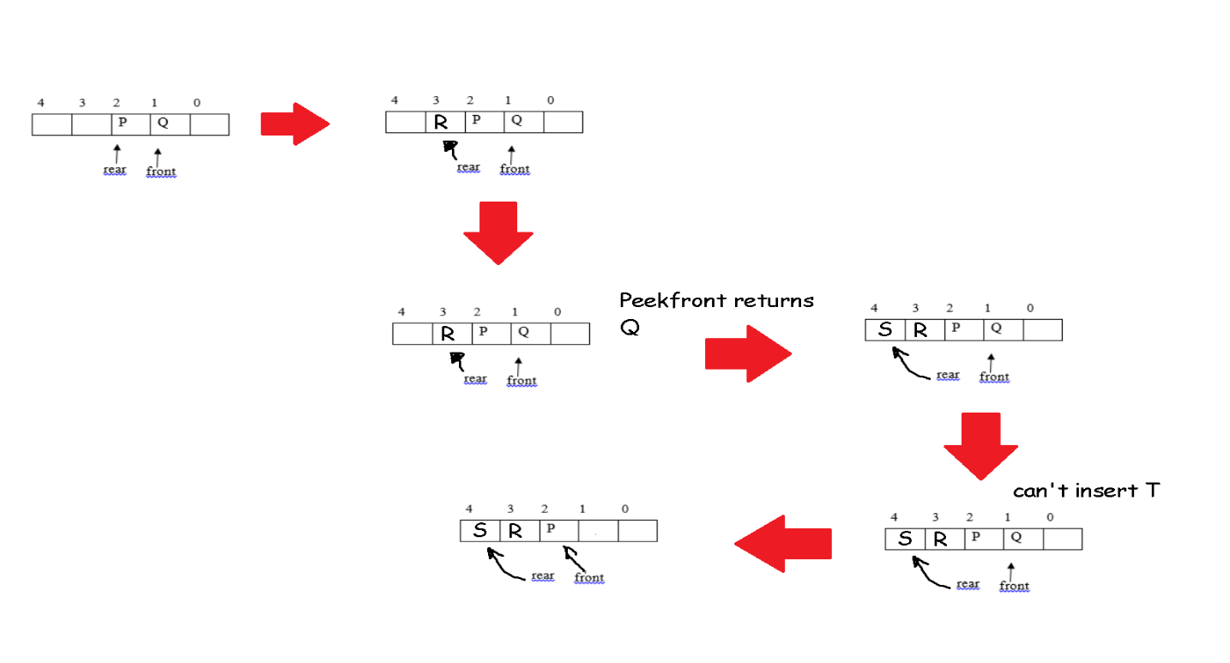

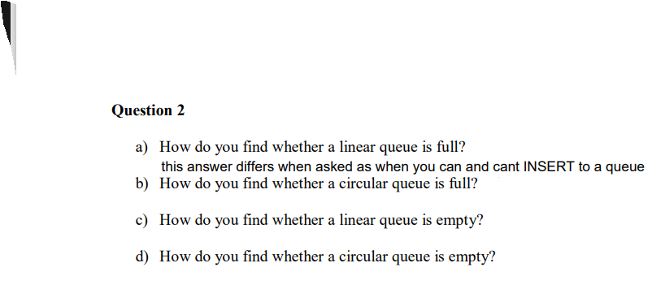

1. if(nItems == maxSize)
2. if(nItems == maxSize)
3. if(nItems == 0)
4. if(nItems == 0)

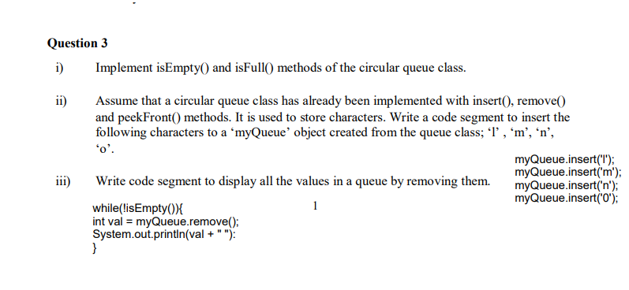



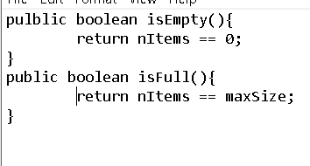

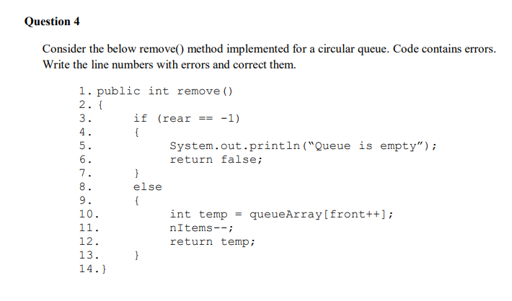

Line 3 should be nItems == 0 because rear might not always be equal to -1

Line 6 should be return -99;

Line 11 should have a statement to reset the rear as

if(rear == (maxSize-1)) {

rear =-1;

}